Christian Garcia

Chris Park

ELEN 164 Lab

6 October 2021

Lab 3: Understanding Power Factor

**Part 1:**

**Section 1:**

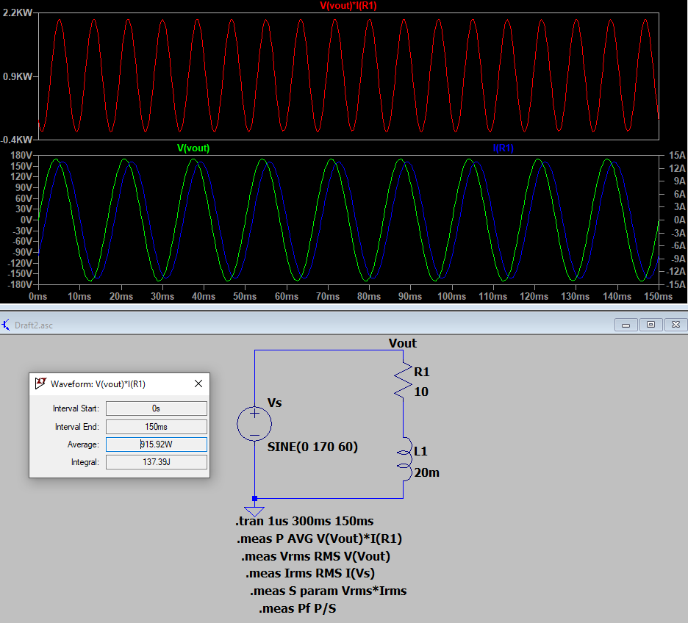

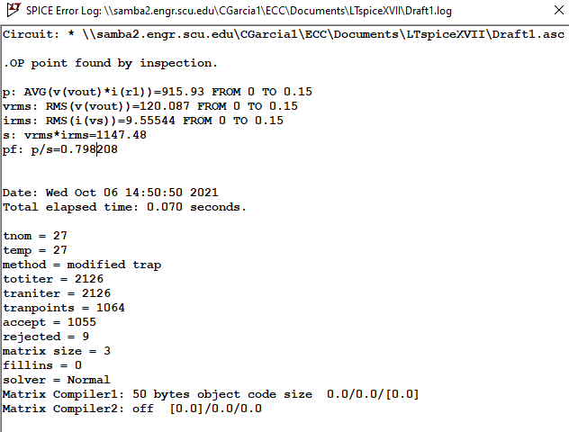

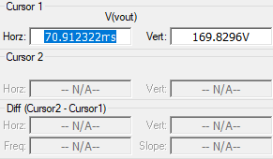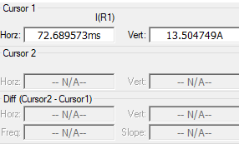

Observations and Calculations:

2. ΔT = 72.689573 - 70.912322 = 1.777251

3. Phase Angle: 1.777251 * (180 / 𝝅) = 101.8289814°

4. PF = P/S; cos (Θ) = P/S

PF = cos(Θ) ---> PF = cos(101.829) = 0.205

6. The power factor we calculated was nowhere near the power factor from the simulation. I believe that this is due to an error in reading the time where the graph peaks correctly. It is really difficult to find the exact peak which provides a lot of room for error.

7. Going based off of the power factor from the simulation I noticed that it wasn’t a great power factor. This means that there is a lot of voltage drop within the system, which isn’t good for many different systems.

**Section 2:**

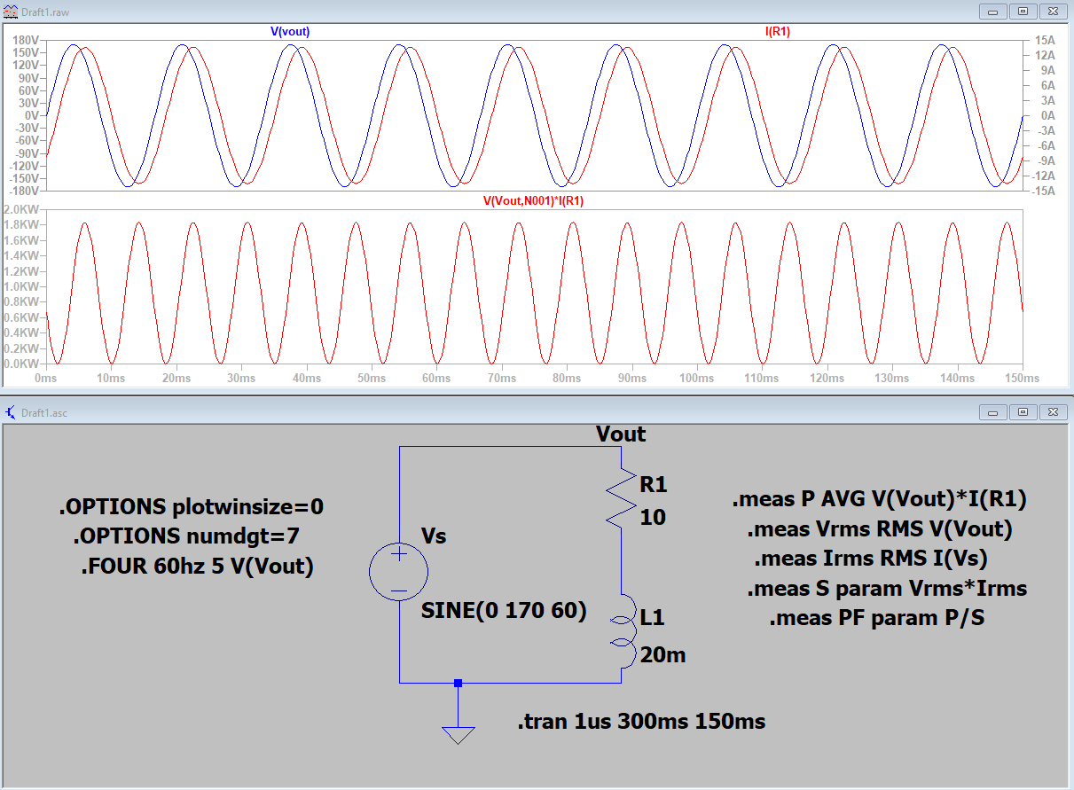

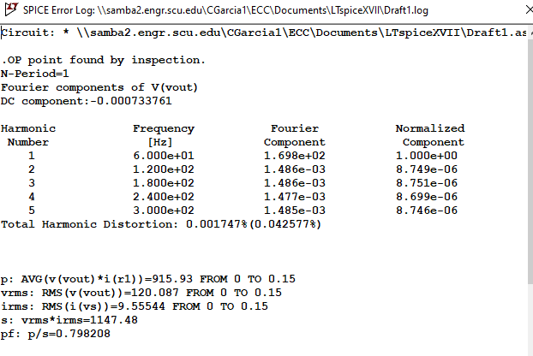

1. What are the frequency components of the output?

From the second harmonic onwards, the frequency component hangs around 8.74*106 with the normalized components in order from the second harmonic to the fifth being 8.749e-6, 8.751e-6, 8.699e-6, and 8.746e-6.

1. What do you see in the output file? Where is most of the energy in the output signal?

The output file lists the frequency components of the first five harmonics, the total harmonic distortion, average power, root mean square voltage and current, apparent power, and power factor. Most of the energy in the output signal is between the amplitudes of the voltage and current signal and the amplitudes of the power signal.

**Section 3:**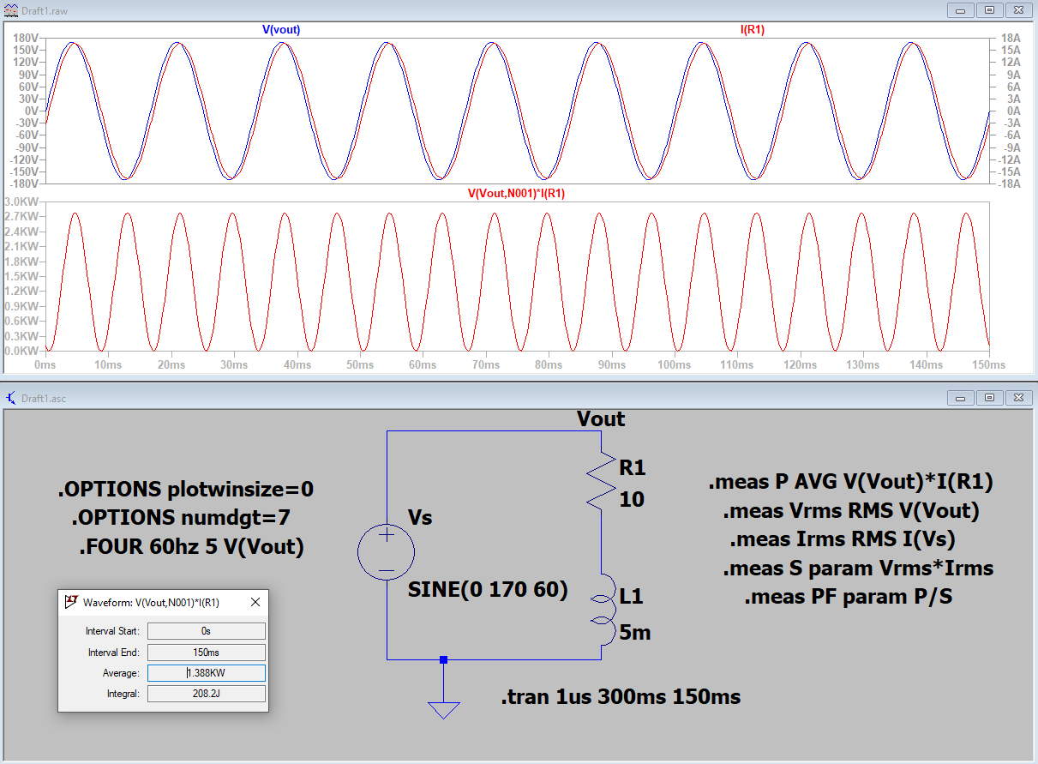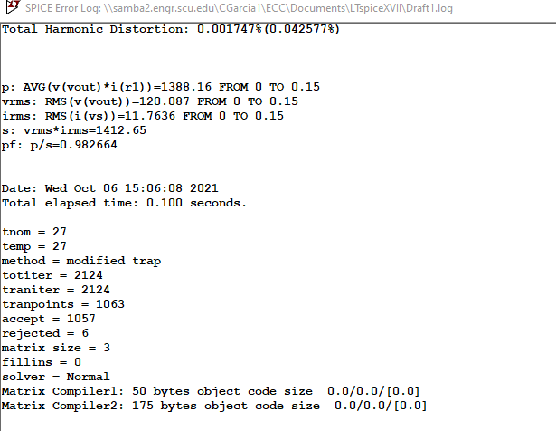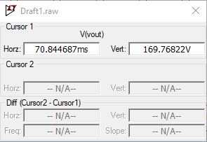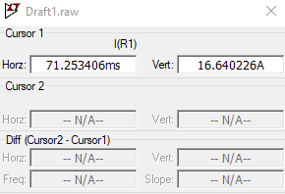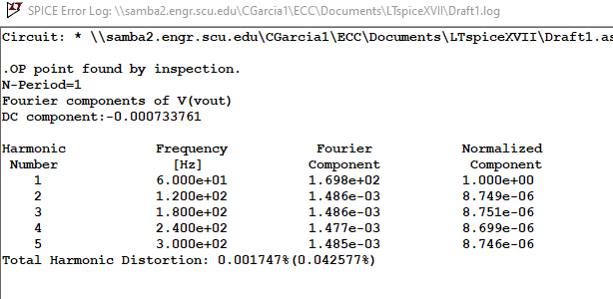

1. The reduced inductance was able to get rid of some of the phase angle. The waves became almost on top of eachother.
2. Yes, the results did improve. We can see this in the power factor, which is 0.982664, this is very close to 1 which means that there is very little voltage drop in the circuit which is ideal.

**Section 4:**

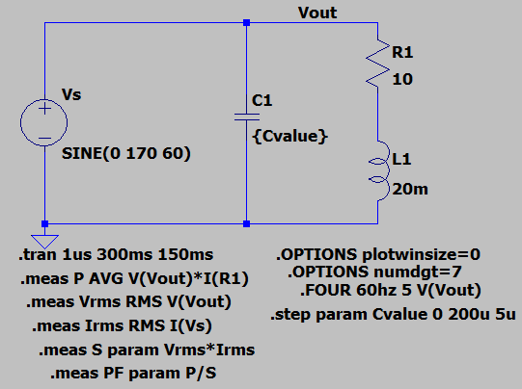

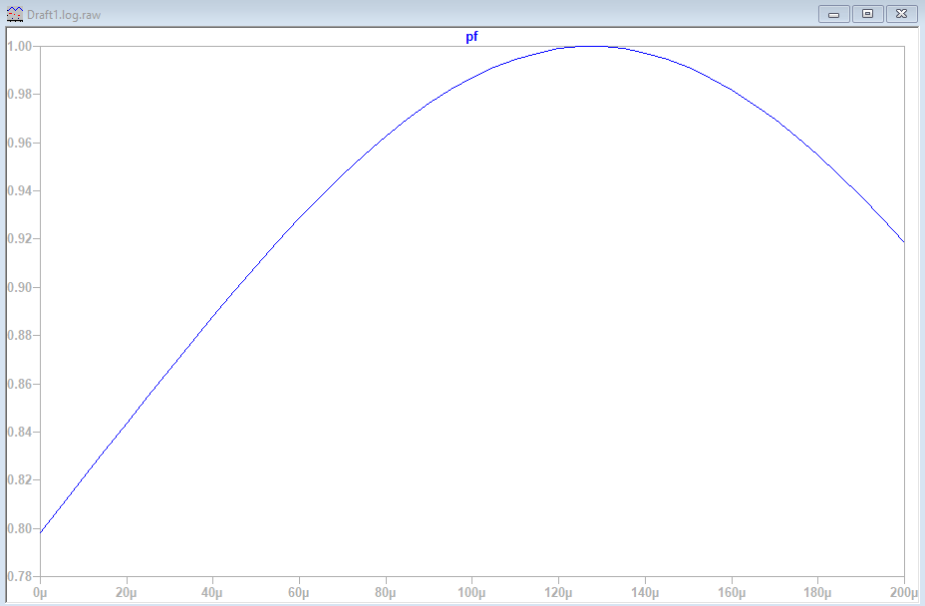

**Observations:**

(1) What is the pf for the capacitance at 0? Explain your answer.

The pf for capacitance at 0 is 0.798208.

(2) Does increasing the capacitance help improve the power factor?

Increasing the capacitance helps improve the power factor, but only until a certain point. At around 130uF the power factor is very very close to 1 but after that it begins to drop again.

**Part 2: Section 1:**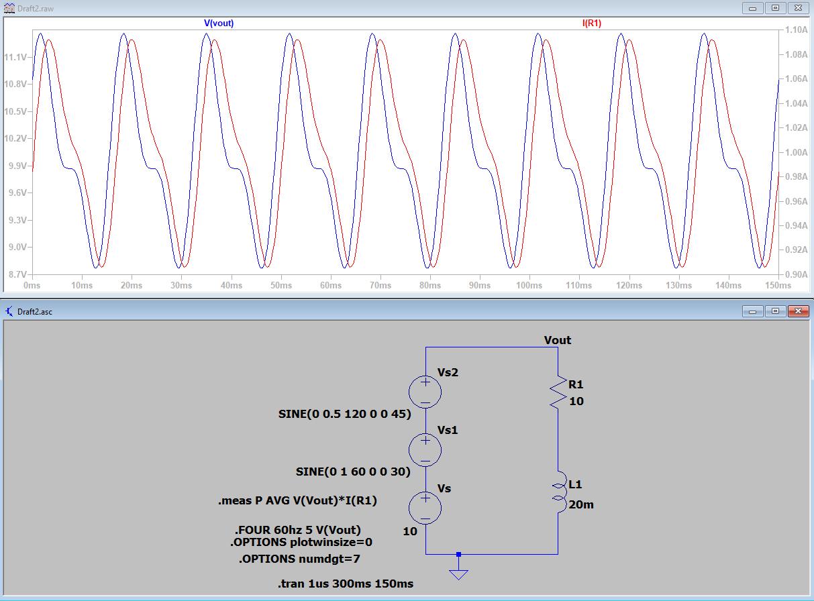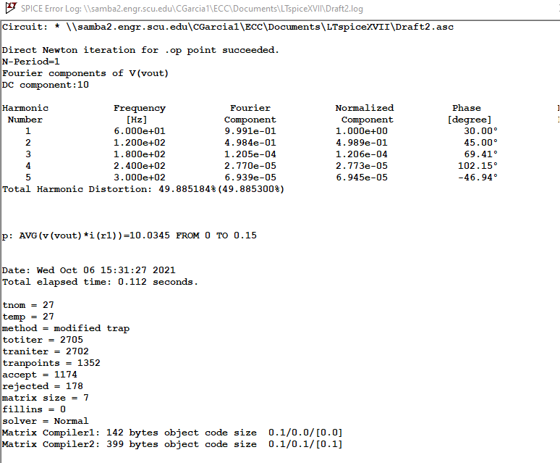

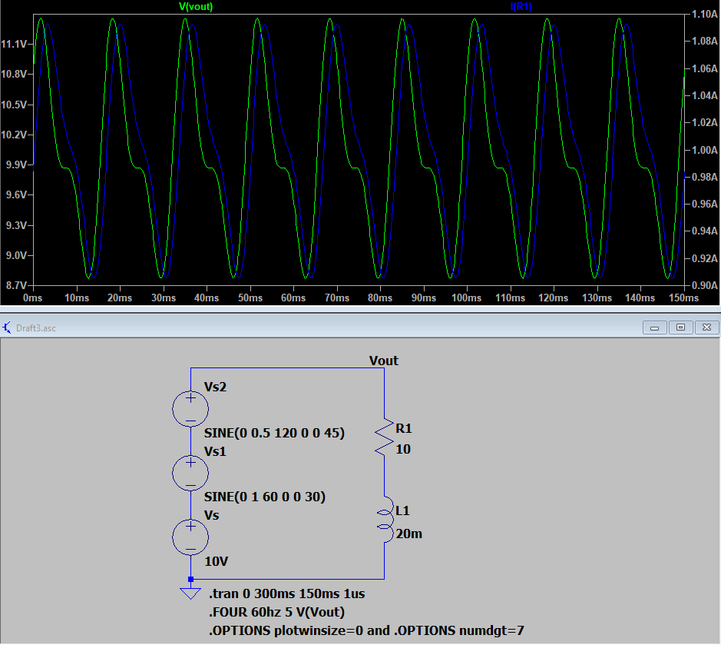

**Observations and Calculations:**

(1) Using measure statements, find the average power. .meas P AVG V(Vout)*I(R1)

The average power is 10.0345W.

(2) What is the harmonic content of the output?

The harmonic content is 49.885%

**Additional Questions:**

1. Look back to Part 1 Section 4, when we did power factor correction. Is there an optimal value for the capacitance for this particular RL load to maximize power factor? Explain why or why not.

Yes, power factor correction can be improved by increasing the capacitance of the capacitor in parallel to the inductive load because it would change the phase difference between the voltage and current signals.

1. Will this have to be recalculated if the load changes? Explain your answer.

Yes, if the resistance load component were to be changed or removed, then the power factor would have to be recalculated.